PRACTICAL 10 – Regression Testing
Project Name: SauceDemo Testing
Module: Login, Inventory, Cart, Checkout, Logout
Testing Type: Regression Testing
Webpage URL: https://www.saucedemo.com/

● Scenario ID: REG_001
Scenario: Login Regression
Test Steps:
1. Enter valid credentials
2. Click Login
Test Input | standard_user / secret_sauce
Expected Result | Inventory page opens
Actual Result | Inventory page opened
Status | Pass
Screenshots:
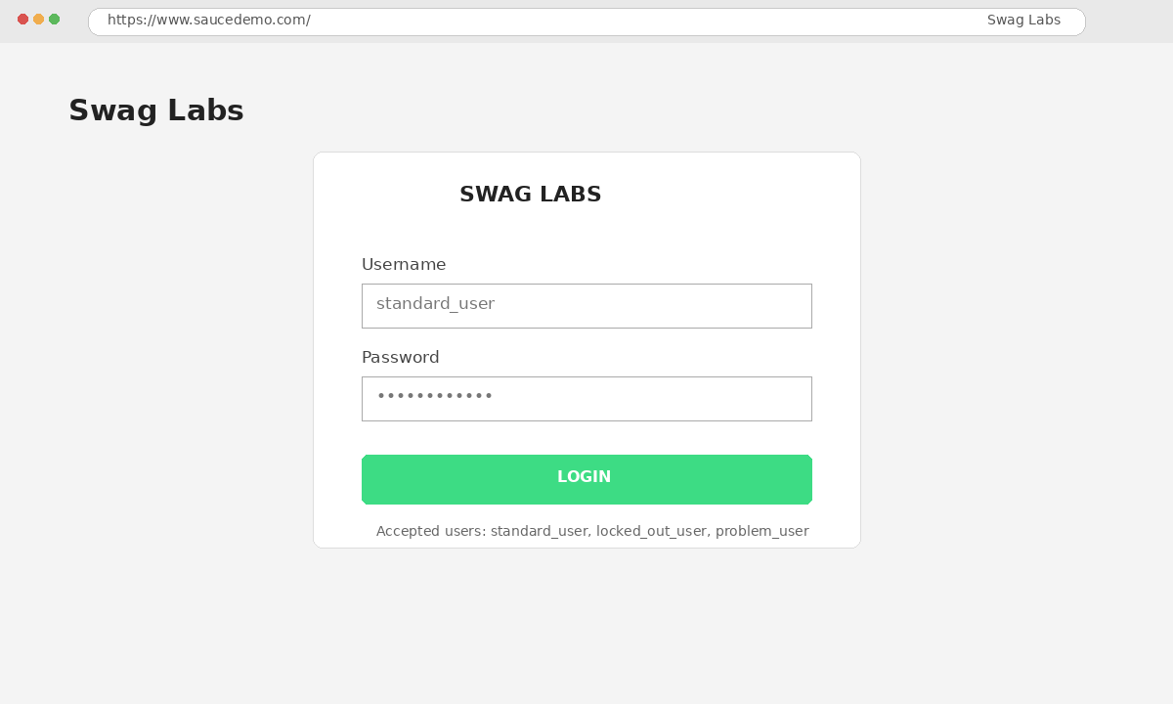
Reference screenshot – Login Regression

● Scenario ID: REG_002
Scenario: Invalid Login Regression
Test Steps:
1. Enter invalid credentials
2. Click Login
Test Input | wrong_user / wrong_pass
Expected Result | Error displayed
Actual Result | Error displayed
Status | Pass
Screenshots:
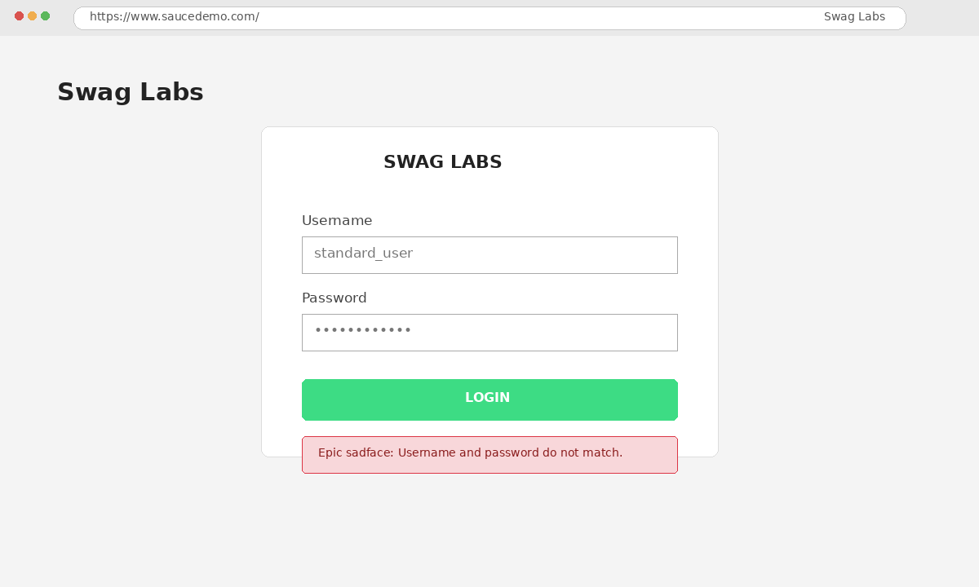
Reference screenshot – Invalid Login Regression

● Scenario ID: REG_003
Scenario: Blank Login Regression
Test Steps:
1. Leave login fields blank
2. Click Login
Test Input | Blank
Expected Result | Validation displayed
Actual Result | Validation displayed
Status | Pass
Screenshots:

Reference screenshot – Blank Login Regression

● Scenario ID: REG_004
Scenario: Locked User Regression
Test Steps:
1. Enter locked user
2. Click Login
Test Input | locked_out_user / secret_sauce
Expected Result | Locked user error displayed
Actual Result | Error displayed
Status | Pass
Screenshots:

Reference screenshot – Locked User Regression

● Scenario ID: REG_005
Scenario: Product Display Regression
Test Steps:
1. Login
2. Open Inventory
3. Verify products
Test Input | Valid login
Expected Result | All products displayed
Actual Result | Products displayed
Status | Pass
Screenshots:
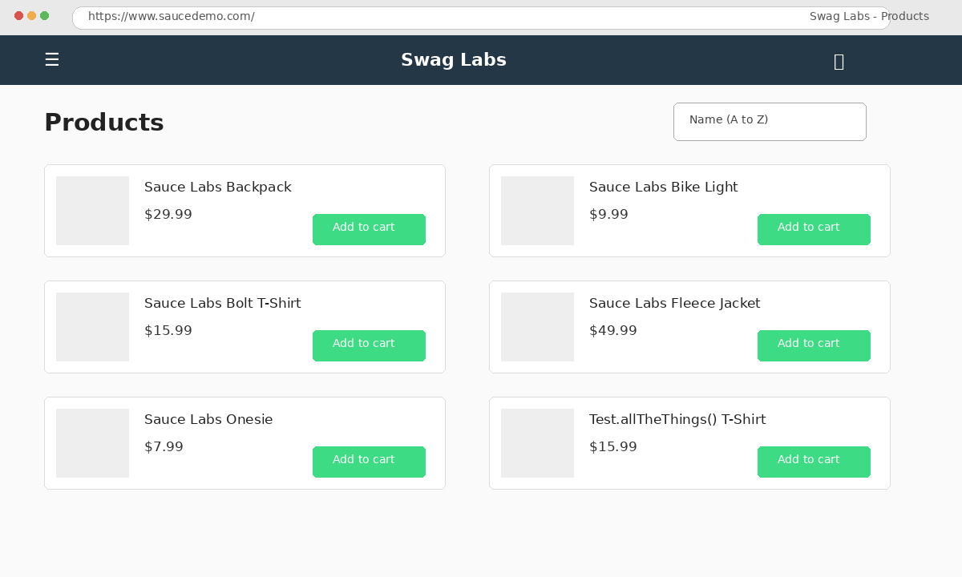
Reference screenshot – Product Display Regression

● Scenario ID: REG_006
Scenario: Product Name Regression
Test Steps:
1. Login
2. Check product names
Test Input | Product names
Expected Result | Correct names displayed
Actual Result | Correct names displayed
Status | Pass
Screenshots:

Reference screenshot – Product Name Regression

● Scenario ID: REG_007
Scenario: Product Price Regression
Test Steps:
1. Login
2. Check product prices
Test Input | Product prices
Expected Result | Correct prices displayed
Actual Result | Prices displayed correctly
Status | Pass
Screenshots:

Reference screenshot – Product Price Regression

● Scenario ID: REG_008
Scenario: Sort A-Z Regression
Test Steps:
1. Login
2. Select Name A-Z
Test Input | A-Z
Expected Result | Products sorted correctly
Actual Result | Sorted correctly
Status | Pass
Screenshots:

Reference screenshot – Sort A-Z Regression

● Scenario ID: REG_009
Scenario: Sort Z-A Regression
Test Steps:
1. Login
2. Select Name Z-A
Test Input | Z-A
Expected Result | Products sorted correctly
Actual Result | Sorted correctly
Status | Pass
Screenshots:
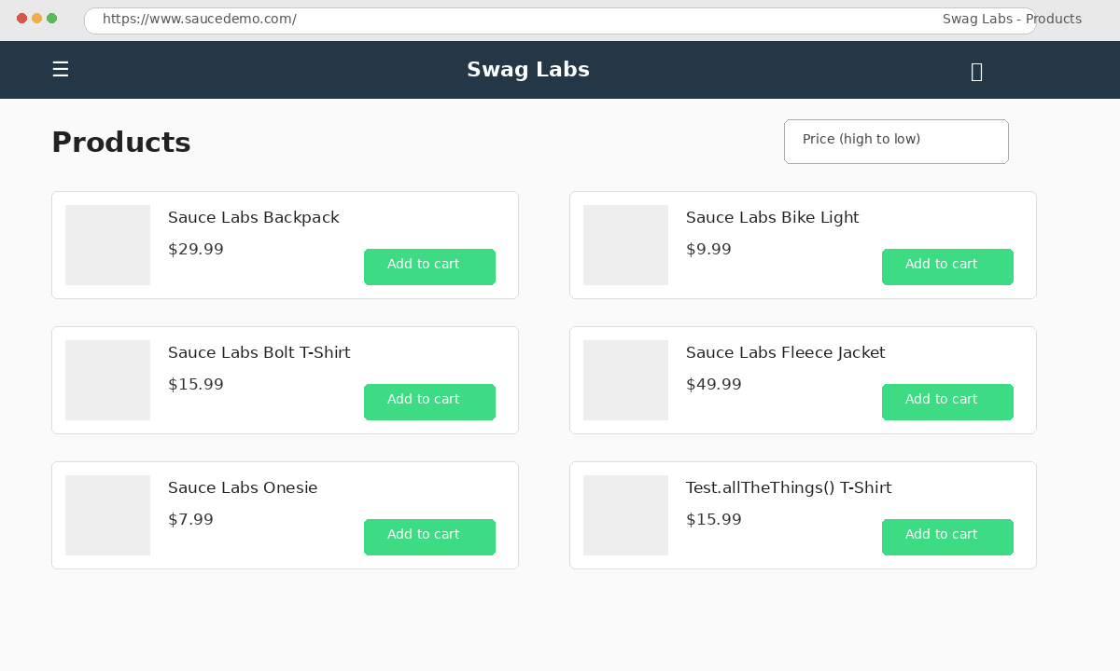
Reference screenshot – Sort Z-A Regression

● Scenario ID: REG_010
Scenario: Sort Low-High Regression
Test Steps:
1. Login
2. Select Price Low-High
Test Input | Low-High
Expected Result | Products sorted by price
Actual Result | Sorted correctly
Status | Pass
Screenshots:

Reference screenshot – Sort Low-High Regression

● Scenario ID: REG_011
Scenario: Sort High-Low Regression
Test Steps:
1. Login
2. Select Price High-Low
Test Input | High-Low
Expected Result | Products sorted by price
Actual Result | Sorted correctly
Status | Pass
Screenshots:

Reference screenshot – Sort High-Low Regression

● Scenario ID: REG_012
Scenario: Add to Cart Regression
Test Steps:
1. Login
2. Add product to cart
Test Input | Backpack
Expected Result | Product added
Actual Result | Product added
Status | Pass
Screenshots:
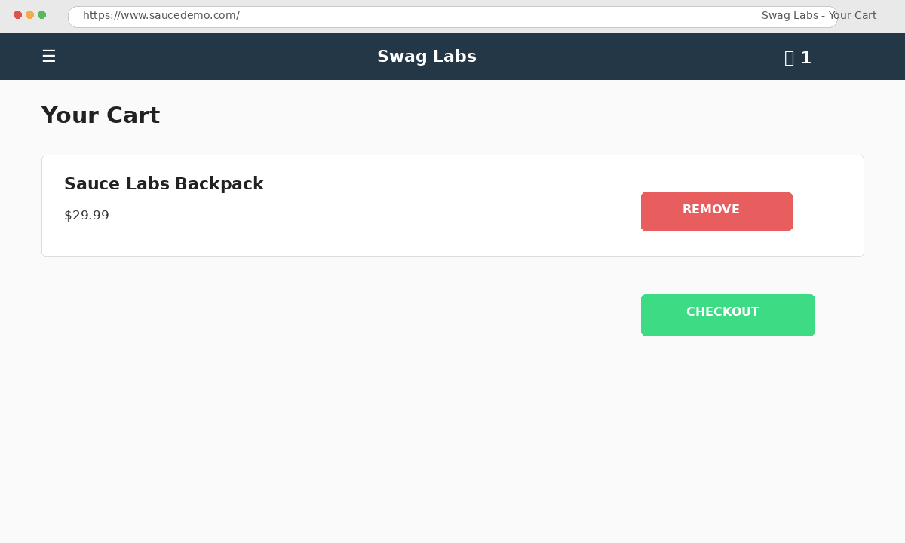
Reference screenshot – Add to Cart Regression

● Scenario ID: REG_013
Scenario: Multiple Cart Regression
Test Steps:
1. Add multiple products
2. Open cart
Test Input | Backpack, Bike Light
Expected Result | Products added
Actual Result | Products added
Status | Pass
Screenshots:

Reference screenshot – Multiple Cart Regression

● Scenario ID: REG_014
Scenario: Remove Cart Regression
Test Steps:
1. Add product
2. Remove product
Test Input | Backpack
Expected Result | Product removed
Actual Result | Product removed
Status | Pass
Screenshots:

Reference screenshot – Remove Cart Regression

● Scenario ID: REG_015
Scenario: Cart Details Regression
Test Steps:
1. Add product
2. Open cart
3. Verify details
Test Input | Backpack
Expected Result | Correct cart details displayed
Actual Result | Details displayed
Status | Pass
Screenshots:

Reference screenshot – Cart Details Regression

● Scenario ID: REG_016
Scenario: Checkout Regression
Test Steps:
1. Cart
2. Checkout
3. Enter details
4. Continue
Test Input | John / Doe / 12345
Expected Result | Checkout page proceeds
Actual Result | Checkout proceeded
Status | Pass
Screenshots:
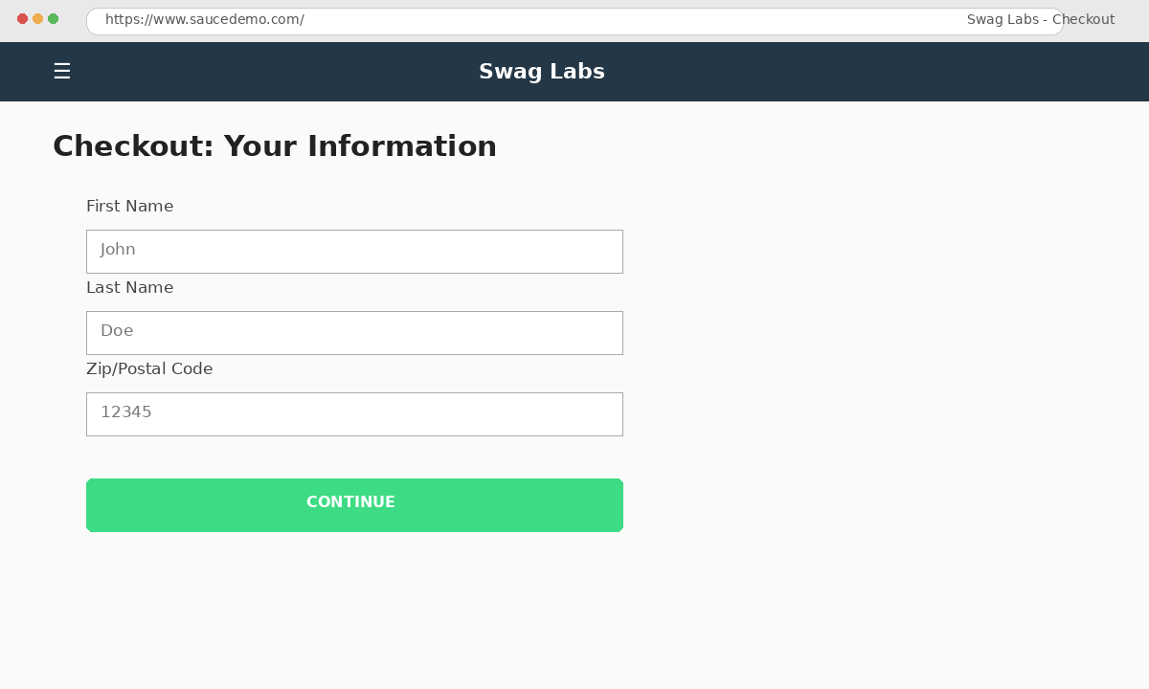
Reference screenshot – Checkout Regression

● Scenario ID: REG_017
Scenario: Checkout Validation Regression
Test Steps:
1. Open checkout
2. Leave fields empty
3. Continue
Test Input | Blank
Expected Result | Validation message displayed
Actual Result | Validation displayed
Status | Pass
Screenshots:

Reference screenshot – Checkout Validation Regression

● Scenario ID: REG_018
Scenario: Order Summary Regression
Test Steps:
1. Enter valid details
2. Continue
3. Verify summary
Test Input | John / Doe / 12345
Expected Result | Order summary displayed
Actual Result | Summary displayed
Status | Pass
Screenshots:
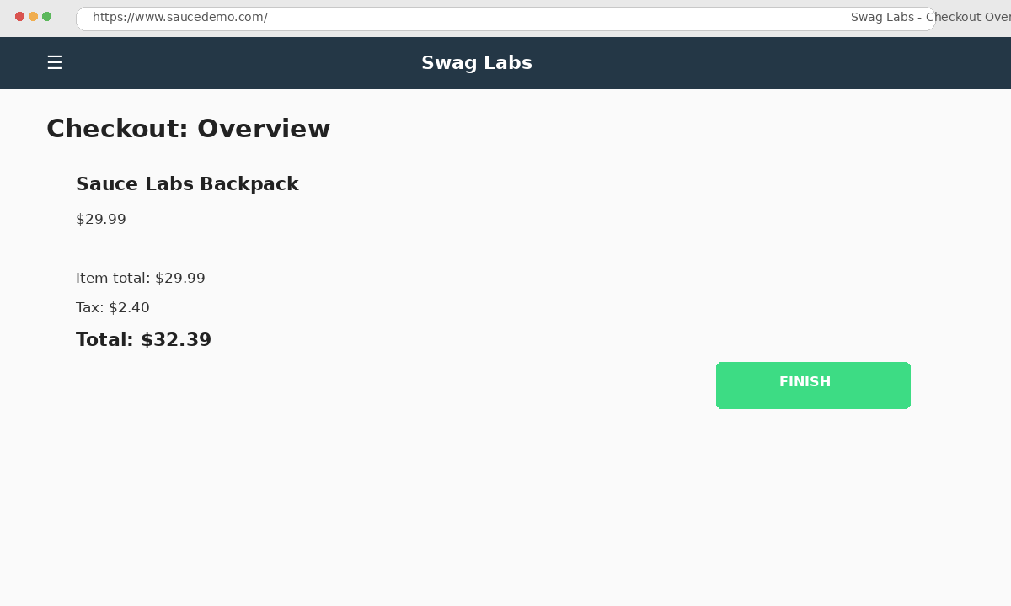
Reference screenshot – Order Summary Regression

● Scenario ID: REG_019
Scenario: Order Completion Regression
Test Steps:
1. Review order
2. Click Finish
Test Input | Valid order
Expected Result | Order confirmation displayed
Actual Result | Confirmation displayed
Status | Pass
Screenshots:
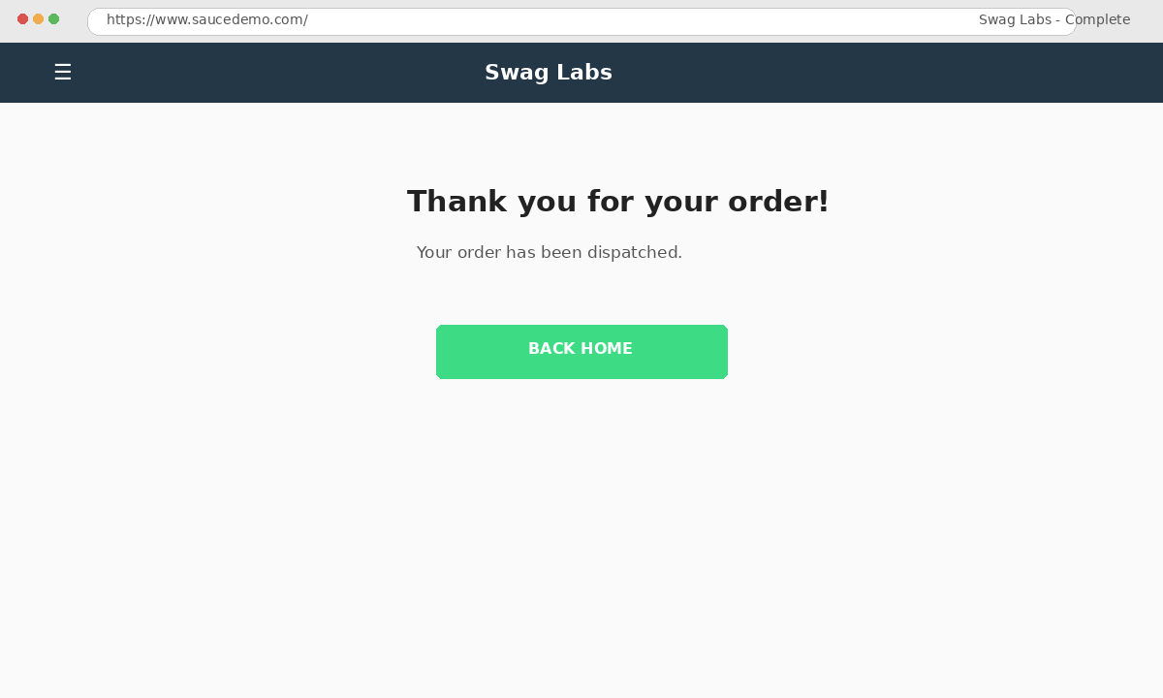
Reference screenshot – Order Completion Regression

● Scenario ID: REG_020
Scenario: Logout Regression
Test Steps:
1. Login
2. Open menu
3. Logout
Test Input | Valid user
Expected Result | Login page displayed
Actual Result | Login page displayed
Status | Pass
Screenshots:

Reference screenshot – Logout Regression

Summary of Test Results
Total Scenarios: 20
Passed: 20
Failed: 0
Automation/Regression Scope: Login, Inventory, Cart, Checkout and Logout modules.

Conclusion and Recommendations

Conclusion
The regression testing practical was completed on the SauceDemo web application. The selected critical and repetitive functionalities were verified and the recorded test cases passed.

Recommendations
Continue automating repetitive and high-priority scenarios with Selenium and reuse the regression suite after application changes.

Bug Report
No defects were observed in the scenarios recorded for this practical.

